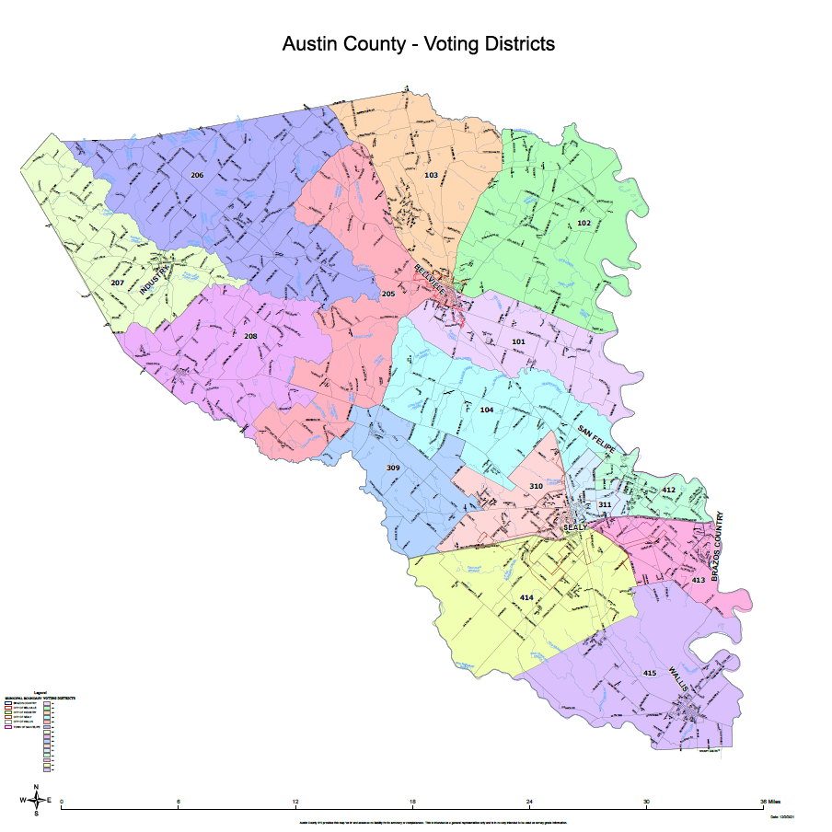

**Sealy Columbus Club Hall**

Re

**Austin County Annex – Wendt Street**

Re

**Austin County Fair and Expo Center**

Re

**Wallis Columbus Club Hall**

**Father Bernard Snock Religious Education Center**

Re

**San Felipe de Austin State Historic Museum – Meeting Room**

**St. John Lutheran Church, Cat Spring**

**New Ulm Volunteer Fire Dept.**

**Industry City Bldg.**

**Bleiblerville Vol. Fire Dept.**

Polling Location 1 Austin County Fair & Expo Center

1076 TX 159, Bellville, TX 77418

Polling Location 2 Austin County Annex – Wendt Street

800 East Wendt Street, Bellville, TX 77418

Polling Location 3 Bleiblerville Vol. Fire Dept.

3912 FM 2502, Bleiblerville, TX 78931

Polling Location 4 Industry City Building

725 Main St., Industry, TX 78944

Polling Location 5 New Ulm Volunteer Fire Dept.

442 Front St., New Ulm, TX 78950

Polling Location 6 St. John Lutheran Church – Cat Spring

480 Ross St., Cat Spring, TX 78933

Polling Location 7 Sealy Columbus Club Hall

1310 Hwy 90, Sealy, TX 77474

Polling Location 8 San Felipe de Austin State Historic Museum – Meeting Room

220 2nd Street, San Felipe, TX 77473

Polling Location 9 Father Bernard Snock Religious Education Center

10471 Grotto Road, Sealy, TX 77474

Polling Location 10 Wallis Columbus Club Hall

730 Columbus Road, Wallis, TX 77485